By P. K. MUTETI

 patrickmuteti355@gmail.com

**ORGANISATION OF THE HEALTH CARE SYSTEM IN KENYA.**

**Objectives.**

By the end of this module, The student should be able to:

1. Explain the concepts of health systems and health systems management.

2. Identify and discuss the structure, roles and responsibilities of the Kenya health system.

**Teaching/learning strategy.**

Lectures, individual assignments, case studies, group discussion, demonstrations.

**Teaching/learning resources.**

LCD, Laptop computer, charts, videos, whiteboard, marker pens.

**References.**

HSM (KMTC) Manual 2014.

Kenya health policy 2012 – 2030. The Health System Assessment Approach.

Vision 2030.

**Terminology definitions.**

**Health System Management (HSM) – WHO.**

Is the coordination of provision of preventive, curative, promotional or rehabilitative health care services through effective management of facilities, HRH, financial and other resources.

**Health services manager** is someone who spends a substantial proportion of his/her time **managing.**

**Resources** such as staff, budgets, drugs, equipment, buildings and information, including planning, implementation and evaluation; staff, budgets, drugs, equipment, buildings and information service users, and partners.

**Health Systems** includes.

1. The **individual patient**, family and the community. Assume a vital responsibility for health promotion and curative care for its members.

2. **Health Care services**. Community health facilities to tertiary health facilities

3. **Health care team**. Staffing. Clinicians, Nurses, Pharmacists. Private Health Care (legal or illegal), churches, Red Cross Traditional birth attendants, Herbalists, alternative health care provider, diviners.

4. **Health economics**. Cost of health care, medicines and drugs.

5. The **Health related sectors**. Education, Agriculture, Water and sanitation and Transport and communication. Contribute to health directly or indirectly

6. The **political and economic environment**. (Regulatory, financial) that influence the structure and performance of health care.

7. The **international sector**, donor agencies (UNICEF, WHO, etc.) Support health and development activities.

**Functions of a Health System.**

A health system is made up of six **groups or building blocks** according to WHO (2007)

1. **Leadership and governance**. ensuring strategic policy frameworks exist combined with effective oversight, coalition building, regulation, attention to system-design and accountability.
2. **Health financing system**. raises adequate funds for health
3. Service delivery
4. **Human resources for health (HRH)**. works in ways that are responsive, fair and efficient to achieve the best health outcomes possible, given available resources and circumstances.
5. **Medical products**, vaccines and technologies of assured quality, safety, efficacy and cost effectiveness, and their scientifically sound and cost-effective use
6. **Health information systems (HIS).** ensures the collection, production, analysis, storage, dissemination and use of reliable and timely information on health determinants, health system performance and health status.

Each **building block interacts** with and influences **the other**.

The **six building blocks** contribute to the strengthening of health systems

Leadership / governance and health information systems provide the basis for the overall **policy and regulation** of all the other health system blocks.

Key **input** components to the health system include specifically financing and the health workforce

Medical products and technologies and service delivery, reflects the immediate reflects the immediate **outputs o**f the health system, i.e. the availability and distribution of care.

**The Kenya National Health System**

The health care system in Kenya include the National Government Health system and a County Government Health system.

Health financing institution, health regulations, all health workers both in the public and private sectors,

traditional, complementary and alternative health care providers,

Professional societies (like Kenya Clinical Officers Association, KMA) who are involved in ensuring the promotion, prevention, control and treatment of illness, care and or rehabilitation of health.

**Structure of the Health Care System in Kenya**

Coordination. **Management.** Organization

1. National. **MOH Headquarters** National referral services.

**and parastatals.** Manage referral services at all

secondary and tertiary referral facilities.

1. County health management. **Hospital management team.** County health

services for all level four facilities

1. Sub county. **Health facility management team**. Comprise of all level 2(dispensary) and 3 (health centres) facilities.
2. Community health committee. **Community health services**. Comprise of

Community units in the county

**Public Sector Health Service Delivery**

Include.

1. The Ministry of health (MOH)
2. Parastatal organisations
3. The private sector, (private for-profit, non-governmental organizations (NGOs) and faith-based organizations (FBO) facilities).

The public sector system account for about 50 per cent of these facilities.

**Public Sector Health Service Delivery System**

Level 1: Community

This is the foundation of the health service delivery priorities. Through engagement with health workers, communities define their own priorities and develop **ownership and commitment** to health services.

Health behaviour change activities through public health information sharing and skills enhancement.

Level 2: Dispensary/ clinic

Dispensaries and clinics primarily handle promotive and preventive care. They are the health system’s first line of contact with patients, but in some areas, health centres or even sub-county hospitals are effectively the first points of contact.

They are staffed by enrolled nurses, public health technicians, and dressers (medical assistants). Services- Curative, rehabilitative, preventive, and promotive services, health census of the population in catchment area, record-keeping and reporting activities, coordinating information flow from facilities in catchment area.

Level 3: Health centre, maternity home, nursing home

Health centres are staffed with clinical officers occasionally by doctors nurses and midwives.

Provides ambulatory health services, preventive and curative services, basic curative and minor surgical services such as incision and drainage preventive services for adults and children, reproductive health services, outreach services, and refer severe and complicated conditions to the appropriate level, such as the County hospital.

Level 4: Primary hospital (Sub county).

Sub-County hospitals provide the first referral level. They form an integral part of the County health system.

They provide: Curative and rehabilitative services, Clinical supportive and supervision, health behaviour change, referral services, logistical support to lower facilities, Co-ordination of collection and dissemination of health information flow.

Level 5: Secondary hospital (County referral hospital)

Level 5 facilities provide referral services at the county level, specialised care, involving skills and competence not available at lower level hospitals, Oversee the implementation of health policy at the county level, maintain quality standards, and coordinate and control all county health activities, Provide training services and internship for health workers, referral for curative and specialised care services, management and coordination support to lower level facilities.

Health professionals working at this level include medical professionals such as general surgeons, general medical physicians, paediatricians, general and specialised nurses, midwives, and public health staff.

Level 6: Tertiary hospital (National referral hospital)

National referral hospitals: There are two national referral hospitals in the country: Kenyatta National Hospital in Nairobi and Moi Referral and Teaching Hospital in Eldoret. The equivalent private referral hospitals are Nairobi Hospital and Aga Khan University Hospital. Specialised hospitals (Psychiatric and Rehabilitation Hospitals):

These facilities render specialist psychiatric and rehabilitation hospital services. They provide sophisticated diagnostic, therapeutic, and rehabilitative services, training services of specialised health cadres, specialised care services, provision of internship, management and coordination support to the provinces and districts, partnership and linkages activities at Ministry of Health - MOH level.

Source: Ministry of Health (2006).

**Responsibilities for health services** are exercised at three levels.

i. The Ministry of Health (National Directorates for Health).

ii. County Health Management Teams (CHMT).

iii. County Health Facility Management Teams.

**The Ministry of Health** (MOH)

Key mandates of the MOH are:

i. Development of national policy;

ii. Provision of technical support at all levels;

iii. Monitoring quality and standards in health services provision;

iv. Provision of guidelines on tariffs for health services;

v. Conducting studies required for administrative or management purposes.

The Chief Technical Officer of the Ministry of Health is the Director of Medical Services (DMS).

National functions are distributed amongst **six directorates** namely:

i. Administrative Services;

ii. Health Standards, Quality Assurance and Regulations;

iii. Curative and Rehabilitative Services;

iv. Policy Planning and Health Care Financing;

v. Preventive and Promotive Services;

vi. National Quality Control Laboratory.

**National Directorates for Health**

**Role** is provide overall direction on Policy formulation, national strategic planning, priority setting, budgeting and resource mobilisation, regulating, setting standards, formulating guidelines, monitoring and evaluation, and provision of technical backup to the county level.

**ORGANIZATION STRUCTURE. MOH STRUCTURE ORGANOGRAM**

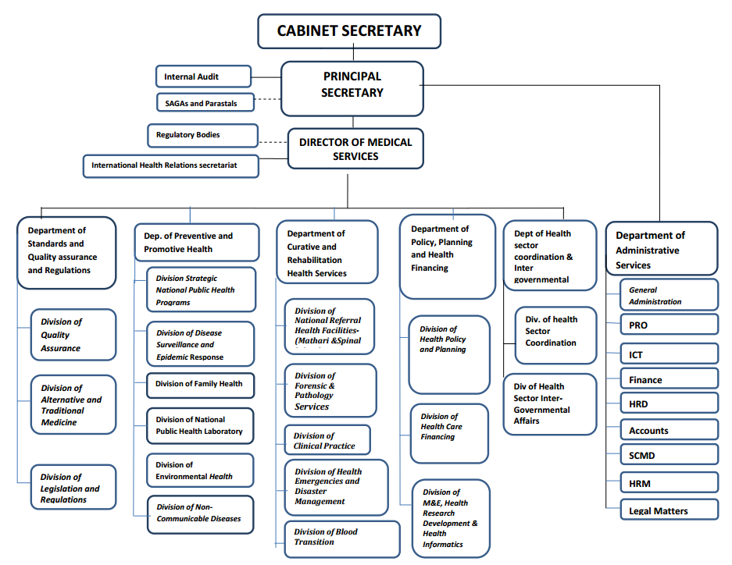

Who is the CS for health in Kenya.

Who is the PS for MOH in Kenya

Who is the CEC for health in your home County?

Who is the CEC for health in your home County?

**Functions of department of curative and rehabilitation health services**

Increased access to quality clinical care in slum areas-Increased access to emergency medical care and disaster management-Increased access to quality national forensic and pathology services

**Functions of department of preventive and promotive health**

Prevalence and incidence of preventable conditions-Level of public awareness and of practice of positive health behaviours

Core mandate of MOH

1. Health Policy and Standards Management
2. Preventive, promotive and curative health services
3. National health referral services
4. Health education management
5. Health inspection
6. Quarantine administration
7. Coordination of campaign against HIV/AIDs
8. Cancer Policy
9. Training of Health Personnel
10. Registration of Doctors and Para-medics
11. National Medical Laboratories Services
12. Pharmacy and Medicines control
13. Public Health and Sanitation
14. Policy Management
15. Medical Services Policy
16. Reproductive Health policy
17. Nutrition Policy

**County government**

The role of the county government is to provide strategic and operational leadership and stewardship for overall health management in the county, including provision of health services, resource mobilisation, creation of linkages with national level referral health services, monitoring and evaluation, coordination and collaboration with state and non-state stakeholders at the county level.

**T**he Kenya Health Policy 2012-2030 proposes the formation of **county** **health departments** whose role is.

“Coordinating and managing the delivery of health care mandates and services at the county level”. provide strategic and operational leadership and stewardship for overall health management. resource mobilisation, creation of linkages with national level referral health services, monitoring and evaluation, coordination and collaboration with state and non-state stakeholders at the county level.

**Health facility management teams**

Providing health services, developing and implementing facility health plans, coordinating and collaborating with stakeholders through County Health Stakeholder Forums, supervising, continuously monitoring and evaluating health service provision and implementing health policies.

Source: Kenya Health Policy 2012-2030.

**Services provided in various levels of health facilities**

ORGANIZATION OF MOH IN DEVOLUTION

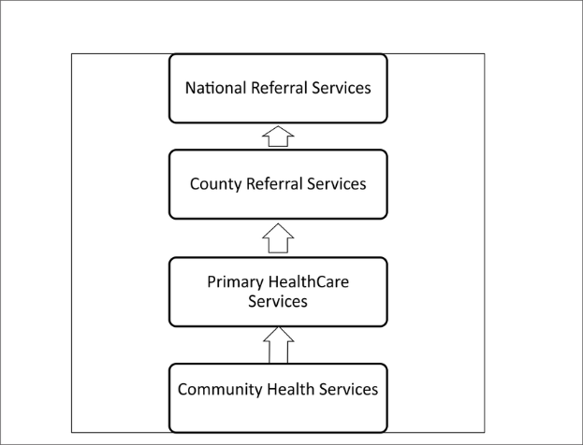

**The MOH is organised into six levels of hierarchy**

Level 1. Community services / facilities.

Level 2. Dispensary and clinics.

Level 3. Health centres. Maternity and nursing homes.

Level 4. Subcounty hospitals, medium sized private hospitals.

Level 5. County referral hospitals and large referral hospitals.

Level 6. Teaching and referral hospitals. KNH. MTRH, Mathari teaching and referral hospital, national spinal injury hospital.

**MOH tiers.**

Tier 1: Community.

Tier2: Primary Care level – levels 2 and 3

Tier 3: County level – level 4

Tier 4: National level – levels 5 and 6

**Role of Ministry of Health (MoH) in service delivery.**

Curative Services. Level 4, 5 and 6

Health Promotion & Prevention. Level 1, 2 and 3

Key **system actors.**

1. The public sector represented by MoH and other government institutions
2. The private health sector (being private for-profit and private not-for-profit) Alternative medicine practitioners
3. Individuals and households that ensure care and support for their families and
4. The communities they live in
5. Development Partners

**Ministry of Health** (**MOH) levels and Functions / Responsibilities.**

**Level 1. Responsibilities - Community health facility.**

Staff – Community Health workers – CHWs, community health volunteers CHVs, community health medical health workers CHMHW, community members.

Give services at homes and homesteads in health prevention measures on causes of illness and proper sanitation.

Promote access to services, provide **health** education, support care delivery, and promote advocacy.

Offer Primary health care**.** Ensure individuals, households, communities carry out appropriate healthy behaviours. Recognize signs and symptoms of conditions that need to be managed at other levels.

Facilitate community based referral.

**Level 2. Responsibilities - Health Dispensaries.**

Staff. Nurses

Offer Primary health care. Outpatient services. VCT services. Tuberculosis services. Laboratory Services. Well baby Clinics. Antenatal and Postnatal services. Pharmacy. Counselling services.

Diagnosis is made through signs and symptoms.

Preventive, promotive health care. Facilitate referral of clients from communities and level three facilities.

Give an example.

**Level 3. Responsibilities - Health Centres**

Staff. At least One doctor, clinical officers and nurses

Offer Primary health early care, outpatient services, MCH/FP, immunization services, Detection, diagnosing and management of diseases

Have a laboratory for routine lab investigations, pharmacy.

No theater. Has a ward. Offer Maternity in-patient services.

Diagnosis is made through investigations

Preventive, curative, promotive, inpatient services.

Give an example.

**Level 4. Responsibilities - Subcounty hospitals**

Staff. Doctors, clinical officers and nurses and other health care providers.

Services offered are outpatient, emergency maternity, basic laboratory, and minor surgical procedures. screening, curative services, secondary health care

Food quality, safety and fortification advocacy, school health programmes or outreach and population management services.

Preventive, curative, promotive, management of lower facilities.

**Level 5 responsibilities - County referral hospitals**

Staff. Medical specialists, Doctors, Clinical officers and nurses and other health care providers .

Offers screening, curative services, secondary health care. Surgical services, including reproductive health.

Training services for various groups of health workers and internships, specialised care **functions,** attendance during childbirth, intensive **care**, and **medical** imaging services, coordinating the management and extending health support to the sub-counties.

Manage all, highly complex patients. and procedures. Act as referral service for all but the most complex service needs.

Preventive, curative, promotive, management of lower facilities.

Facilitate and manage referral from level 2 and 4. Together with other level 3 facilities form county level referral sytem.

County governments manages these hospitals

**Level 6 responsibilities - National Referral Hospitals**

Staff. Medical specialists

Offers. Secondary / tertially health care

**Offer**. Highly specialised consultations in curative care, highly complex, high-risk patients. curative, promotive, rehabilitative, teaching and research services.

Kenyatta National Hospital and Moi Teaching and Referral hospital, Mathari teaching and referral hospital

National Spinal Injury Referral offers specialised services in orthopaedic and spinal injuries.

The national government manages these three hospitals.

**Health services**

* Mental health care.
* Dental care.
* Laboratory and diagnostic care.
* Substance abuse treatment.
* Preventative care.
* Physical and occupational therapy.
* Nutritional support.
* Pharmaceutical care.

**Cadres** in health care services

1. Health Records and Information Officers (HRIOs),
2. Community Health volunteers (CHVs) and
3. Emergency Care Professionals (ECPs).
4. ……………………………………………………………..

**Levels of health care**

Categories of **health care**

**Primary care.** Healthcare provided in the community for people making an initial approach to a medical practitioner or clinic for advice or treatment.

Delivered in outpatient settings, as the low-level **care** and consultations provided to patients do not require hospitalization. Level 1 and 2

**Secondary care**. Is more specialized and focuses on helping patients who are struggling with more severe or complex **health** conditions requiring the support of a specialist.

**Eg. care** is often found in a hospital emergency department. Includes skilled attendance during childbirth, intensive **care**, and **medical** imaging services. "**secondary care**" is sometimes used synonymously with "hospital **care**".

**Tertiary care.** Highly specialized medical care usually over an extended period of time that involves advanced and complex procedures and treatments performed by medical specialists in state-of-the-art facilities. Level 5 and 6. KNH, MTRH

**Quaternary care**

An extension of tertially care in highly specialized centres. National spinal injury hospital, mathari teaching and referral hospital.

**Referral system**:

A comprehensive **health care system** used to manage client **health care** needs by **referring** clients from an initiating facility to an organization, **service**, or community unit that can better provide the level of **care** needed.

**Referral management system.**

Is a unique and powerful tool for **health** providers to keep track of their patient **referrals** throughout the **care** continuum. Its main goal is to improve and streamline communication among primary **care** physicians, specialists, and **health** providers involved in a patient's **care**.

**Referral system in primary health care**

**Healthcare**  providers at lower levels of the **health system** seek the assistance of providers who are better equipped or specially trained to guide them in managing or to take over responsibility for a particular episode of a clinical condition in a patient.

**Actors in healthcare services in kenya**

TheKenyan healthcare systemcan be split into three subsystems, ...

Non-governmental actors such as

1. Non Governmental Organizations - NGOs
2. Faith Based Organizations – FBOs
3. Public health- Private practitioners, herbalists.

References and Recommended Further Reading.

Health Systems 20/20 (2012) The Health System Assessment Approach: A How-To Manual. Version 2.0. Available at <www.healthsystemassessment.org> [Accessed 24 February 2014].

Management Sciences for Health (2005) Managers Who Lead. A handbook for improving Health services (3rd ed). Cambridge: MSH

The end

Continue reading

Stay safe.